**To Create a Group Lookup field**

Go to Parent Entity then click on new entry give the Common Name = Vendors

then click on create…

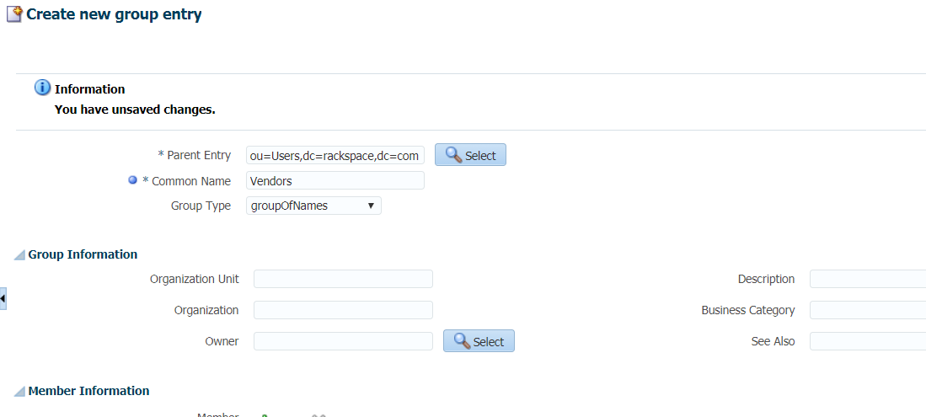

Then run the scheduler job

**LDAP Connector Group Lookup Reconciliation…**

Check in design console in Lookup Definition with Code = Lookup.LDAP.Group

Click on refresh and see…

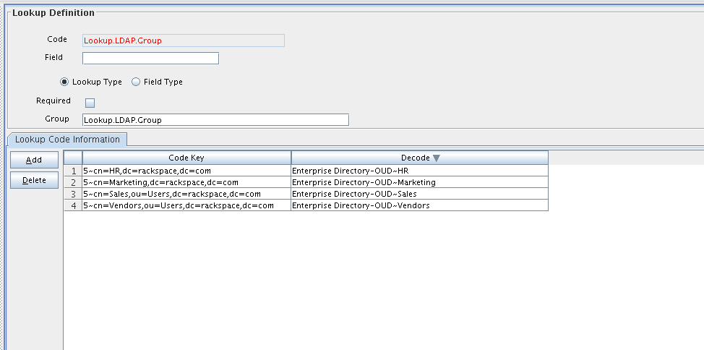

**To create Organization Lookup Fields**

Go to Parent Entity then click on new entry give the Org Name = Contractors

then click on create…

Then run the job of

LDAP Connector OU Lookup Reconciliation

